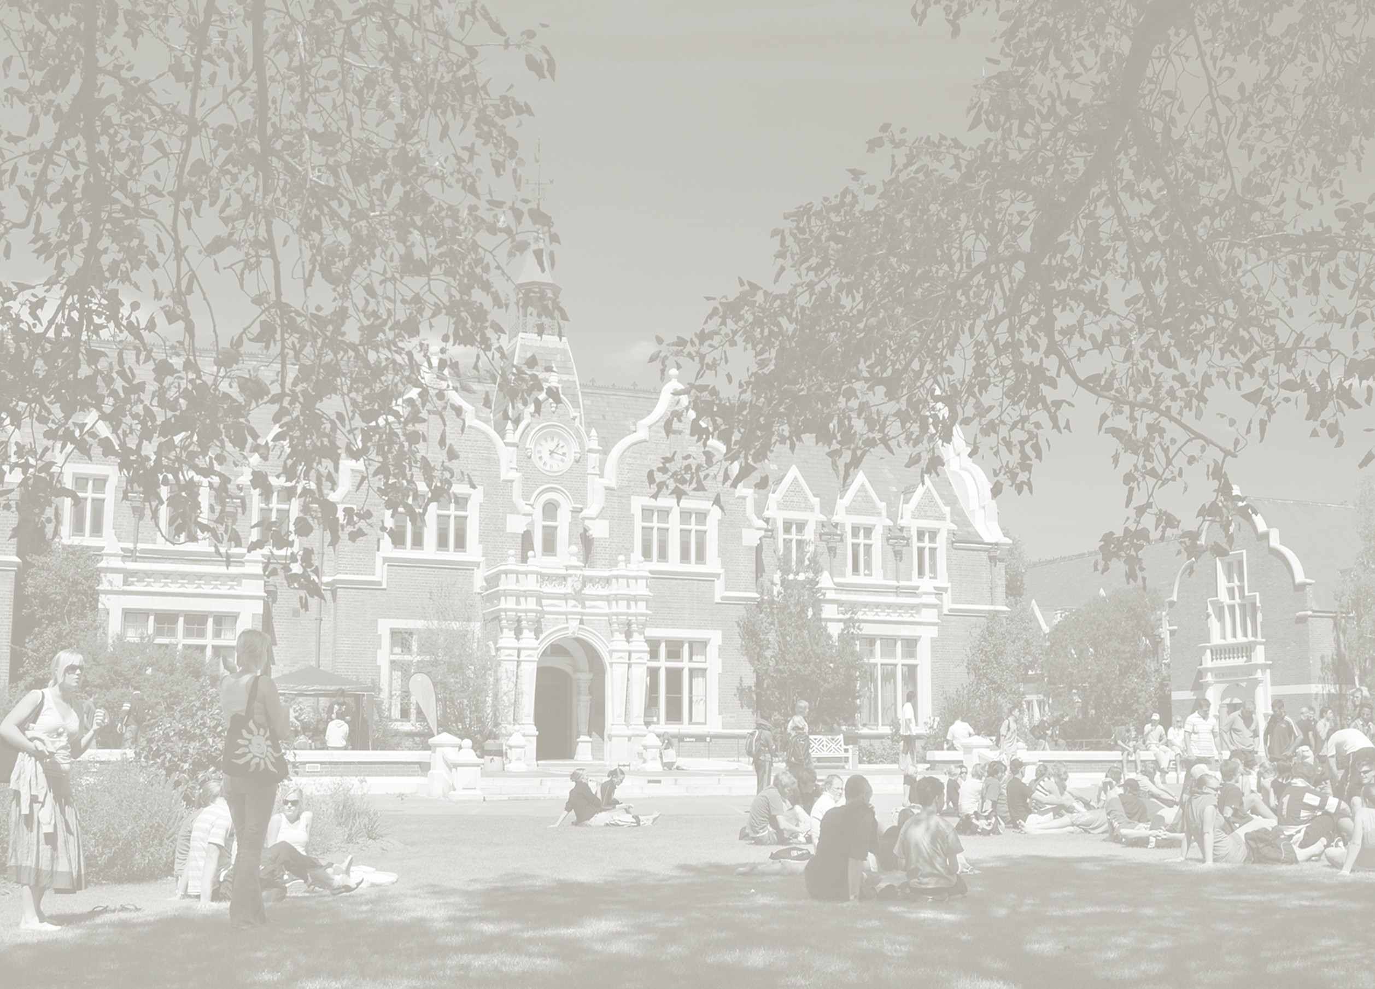
Statement of Research Interest
Master of Planning

Applicant’s name:
Date:
Have you discussed your proposal with an academic staff member?
No Yes
Name of Academic________________________________________

The statement of research interest is used by the University for three main purposes:

- Demonstrate to the University that the applicant has an understanding of what planning is;
- Enable the University to understand the applicant’s interests relating to planning;
- Demonstrate to the University that the applicant has given thought to a potential dissertation research topic;
- Help the University identify potential supervisors.
The statement should be no more than 800 words and it must be written in your own words.

Area of planning interest and possible research topic for your dissertation (dissertations are completed in Y2) (no more than 800 words)

- Submission of a statement does not commit you or the University to undertake the proposed research. Your eventual dissertation topic will emerge as the result of your first year classes and discussions between you and your supervisor.
  - You are able to discuss your research interests with an academic advisor before submitting your application. The academic advisor will be in a position to provide feedback on a draft of your statement.

